**How To Install Window 11**



Session: 2022 – 2026

**Submitted by:**

Ghulam Mustafa 2022-r/2021-CD-CS-2

**Supervised by:**

Sir Nauman Shafi

Department of Computer Science

**University of Engineering and Technology**

**Lahore Pakistan**

# Steps:

* Check your laptop Specifications for Win 11
* Install win11 iso file
* Insert a USB and make it bootable by rufus
* Restart laptop in which you want to install win 11
* Press Ese or F2 to select bootable USB

## Follow these Pictures:

* 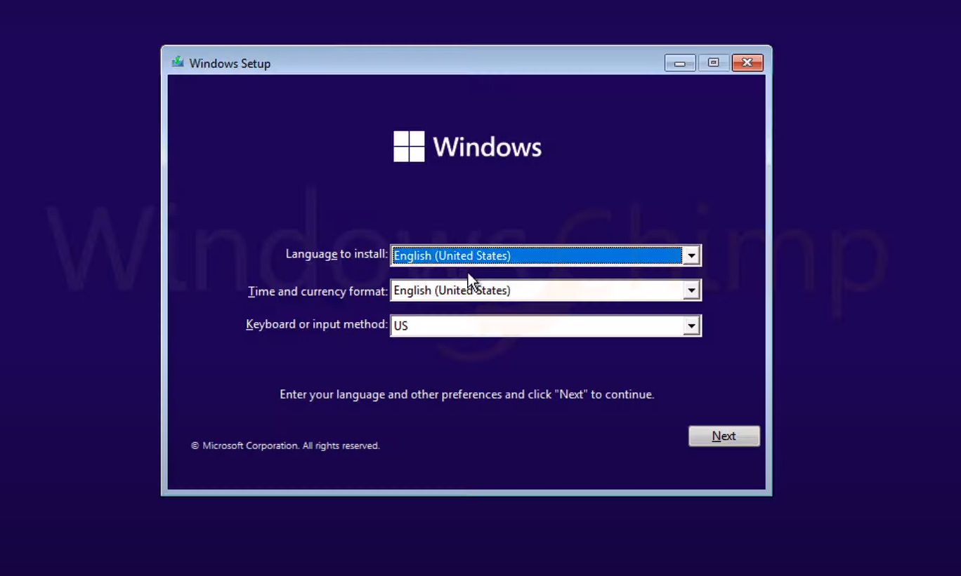Press Next

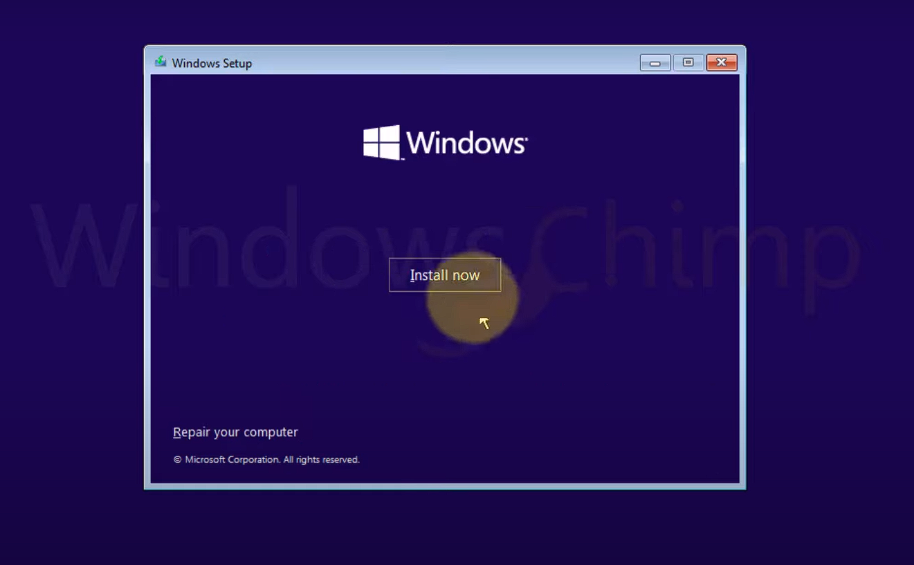



* 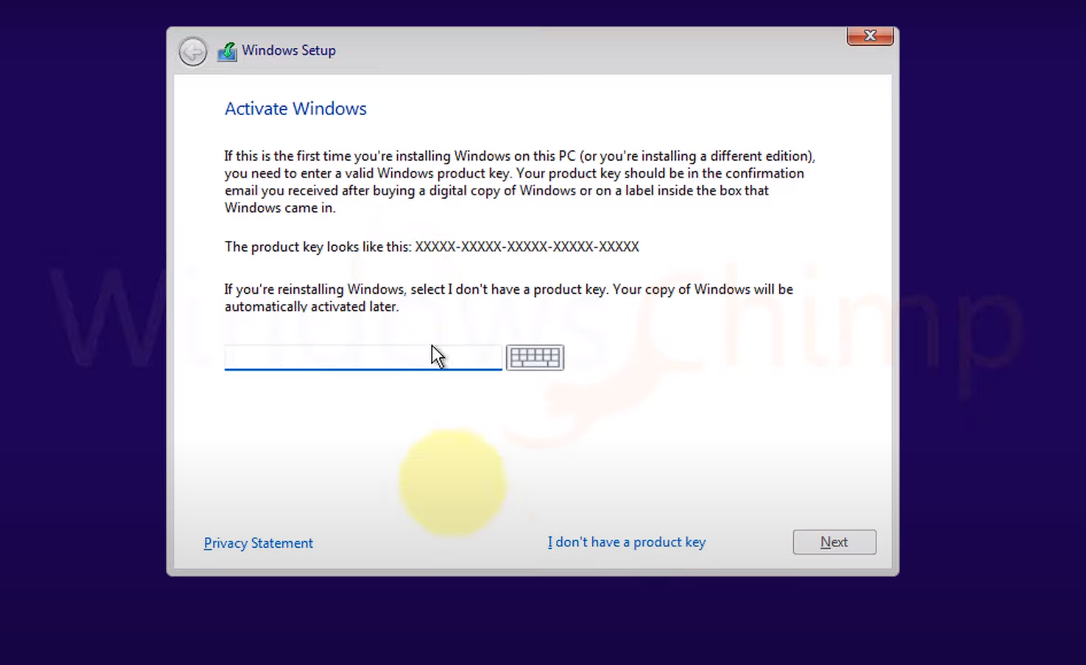Press I do not have license Key
* 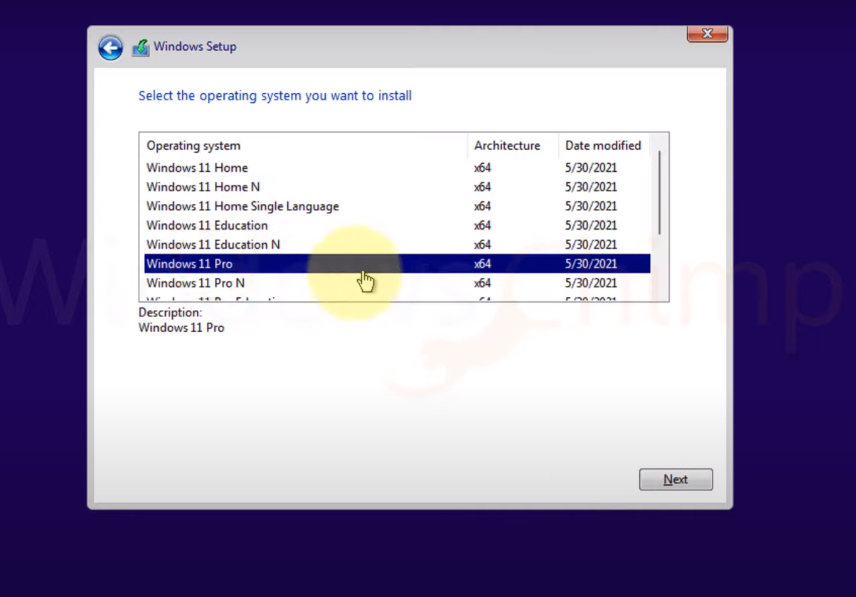Select Window Edition

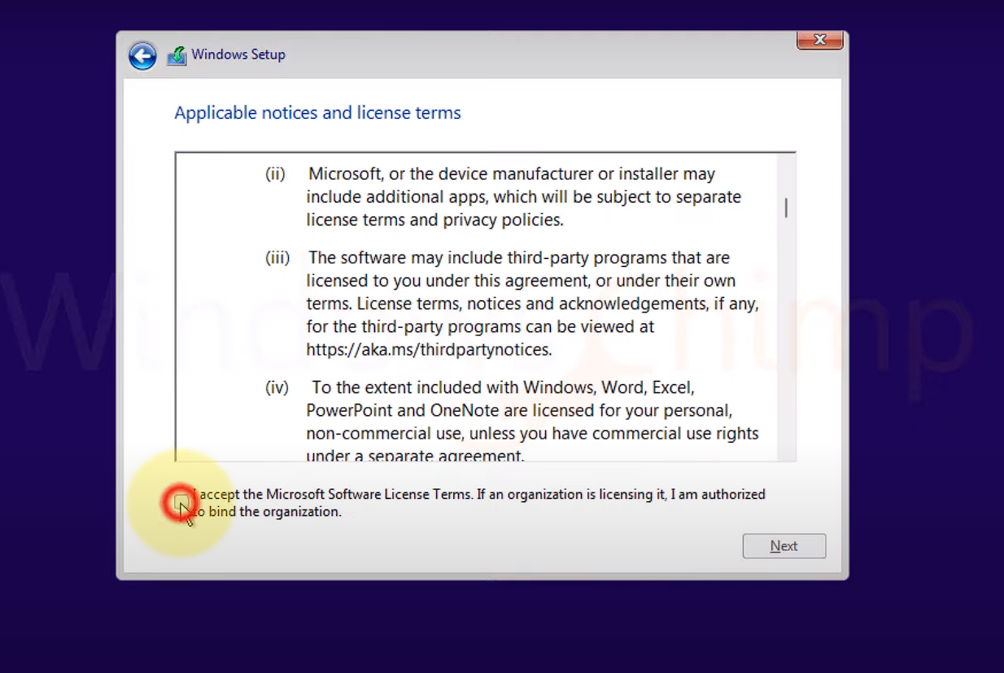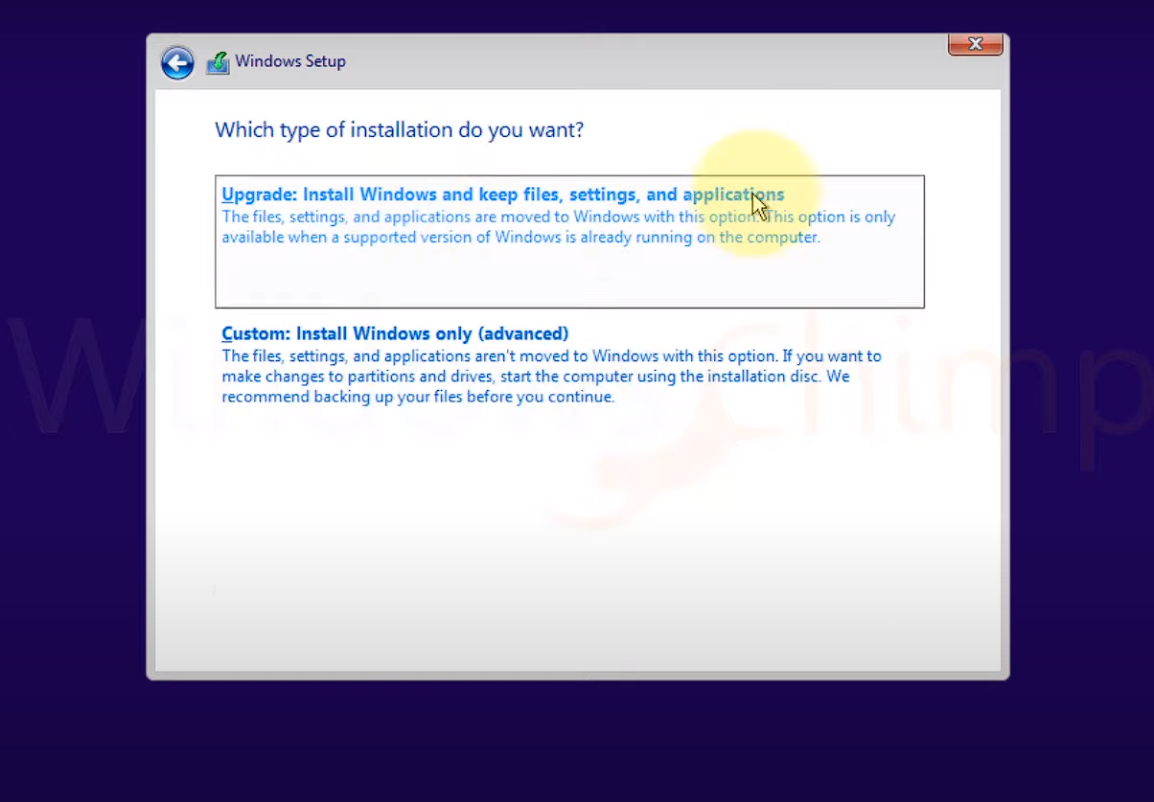

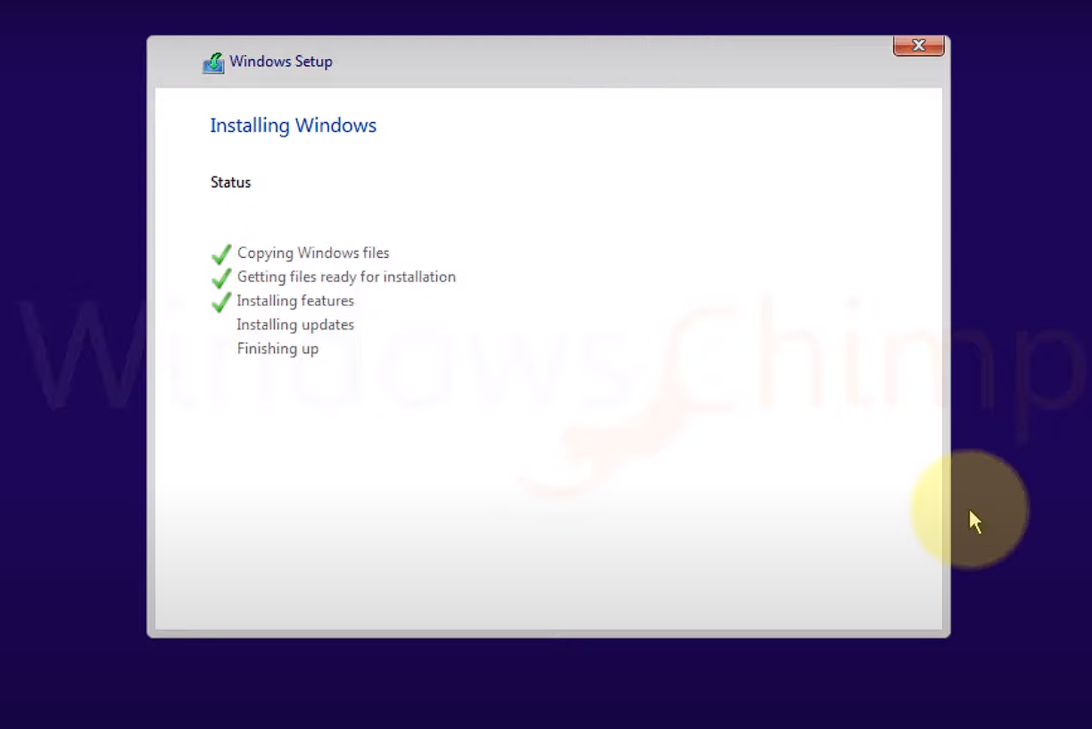

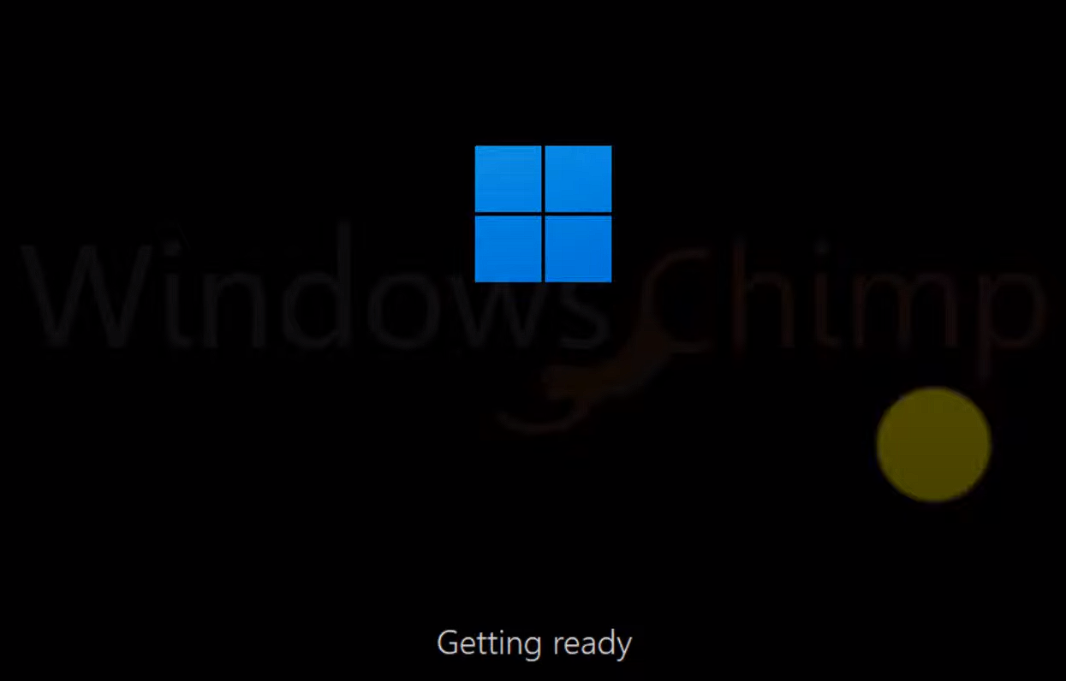

### My Laptop Specifications:

* Lenovo Thinkpad yoga 260
* Operating System : window 10
* Processor : Intel® Core™ i5-6200U Processor (3M Cache, up to 2.80 GHz)
* 4-Logical Processors
* Ram 8Gb ddr4
* Ssd 256 Gb
* 